A Method for Procedural Building Destruction from Houdini to UE4

JiaNi Zhou, Tae Soo Yun

Department of Visual Contents
Graduate School, Dongseo University
Busan, South Korea
moses472530@gmail.com, yntaesoo@gmail.com

Abstract

With the continuous improvement of Unreal Engine 4’s function, Unreal Engine 4 is no longer only used in the field of game development, the production of video content made by Unreal Engine 4 is gradually becoming popular. This paper was to propose a method of procedural building destruction workflow for high-quality visual effects in the form of a Houdini Digital Asset(HAD), also implement procedural building destruction with UE4 what made by Houdini, break through the barriers between the two pieces of software. This workflow brings the advantage of Houdini’s special effects capability to Unreal Engine 4. On the other side, Unreal Engine 4 provides more exhibition space and application opportunities for the special effects produced by Houdini.

Keywords; Houdini; procedural building destruction; Unreal engine 4; workflow

I. Introduction

The fragmentation effect can be seen everywhere in the film and television works. The concrete implementation methods of broken special effects can be summarized into three categories. Firstly, location shooting. It refers to the blasting, collision and other means to destroy the real object or scene, and the actual process of broken objects. Although this production mode can obtain the realistic visual effect, high production costs are inevitable. When it comes to filming security, location shooting is not an ideal solution. Secondly, miniature model photography. Miniature model photography refers to the simulation of the crushing effect by simulating the crushing scene of the miniature model. This method saves the cost of production, but it can't quite simulate the realistic effect on the visual effect. Thirdly, Digital effects. Digital effects are a virtual crushing effect, which is made by using computer graphics technology, combined with modeling, dynamics, rendering and other technologies. This method not only can simulate a variety of crushing effects, and the visual effects are also very close to the truth[1]. Therefore, at this stage of the production in the field of film and television, most producers choose the way of making use of Digital effects to simulate the crushing effect. The film and television work famously for their visual impact are all produced by Digital effects, such as "Inception", "The Day After Tomorrow" and "2012".
The production process proposed in this paper belongs to the field of digital effects, which uses the special effects software Houdini to produce the rigid body crushing effect of the building. And the results of the Houdini production will be imported into Unreal Engine 4 for real-time rendering. This process not only summarizes the broken process of the rigid body in Houdini, and explores how to create special effects into the Unreal Engine 4 material, and it breaks the barriers between the two software. The significance of using Unreal Engine 4 to demonstrate the broken effect is that it is not only used in the field of game development but also can be used to produce video content such as animation or movie. But Unreal Engine 4 is not as powerful as Houdini in the special-effects production plates. Therefore, if the effects of Houdini can be converted into the form that can be used by Unreal Engine 4, the special effects field of Unreal Engine 4 is undoubtedly an important reinforcement. At the same time, Unreal Engine 4 also provides more display space and more application possibilities for Houdini's special effects.

II. Houdini and The Crushing Effects

Fig. 1 illustrates the overall process of producing the rigid body crushing effect of the building and importing the Houdini production into the Unreal Engine 4 for real-time rendering.
A key objective of this study is to figure out how the effects of Houdini can be converted into the form that can be used by Unreal Engine 4. This solution connects Houdini with Unreal Engine 4 as a complete workflow(Fig. 1).

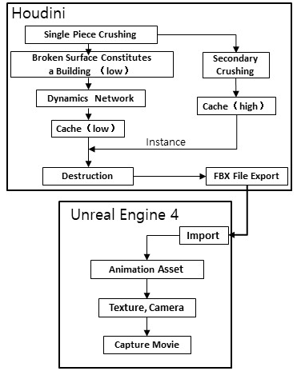

Fig. 1 The Schematic Diagram of Our Method
This section describes the production process of rigid body crushing in Houdini. Also, the process of special effects produced by Houdini importing to Unreal Engine 4 is also presented.

A. Classification of broken effects in Houdini

The crushing effect made with Houdini can be divided into two kinds according to the material characteristics of the broken object. 1.The rigid body crushing. It refers to the phenomenon that the object does not deform when it is subjected to external force, leading to the disintegration of the object, and the rigid body is broken to simulate the collapse of the hard object such as the building collapse and the glass crushing. 2.The soft body crushing. It means that the object is deformed and cannot be restored to its original shape when it is squeezed by an external force. This type of fragmentation is often used in the crash of cars, biological objects hit and other malleable materials. The architectural crushing effects of this paper belong to the field of rigid body crushing, and the hard structure of the building is subjected to internal force and external force, which leads to its own disintegration. In this paper, the physical phenomenon is restored in Houdini by using the model and combining dynamics.

B. Case analysis of Houdini's production of rigid body crushing effects

Because of the powerful function of Houdini software, there are many films and TV works that use it to produce rigid body crushing special effects. The movie "2012" restores the chaos of Los Angeles in the days of the apocalypse, which requires a large number of buildings to collapse(Fig. 2). The production team used the Houdini software geometric fracturing tools and rigid body dynamics simulations to make spectacular buildings collapsed[2]. The movie "Inception" uses the same idea to create the scene of a city collapse in a dream, using a Voronoi diagram to simulate the shape of a broken wall. The film "Captain America: Civil War" also uses Houdini's rigid body image to create a realistic building collapse. "The Day after Tomorrow", "Spider-man: the Return of the Hero" and "Independence Day: Resurgence" all use the Houdini software to create the rigid body crushing effects[3].


Fig. 2 Broken scene in “2012”

III. Analysis of the process of building crushing effects in Houdini

A. Model production

The model is divided into three steps: model building, model splitting and model integration.The first step is the model building. It creates a cube model in the Houdini and changes the shape of the model to the shape of the wall. The second step is model splitting. It uses the scatter node and Voronoi fracture node to split the uneven walls into pieces. Voronoi diagram is a widely used mathematical concept that can produce natural fracture shapes, which has an important guiding role as the core of Houdini rigid body crushing special effects[4]. The third step is model integration. It copies the finished wall model and then splices it together into a complete cube, and makes a cuboid of 3*2*4 after it is copied by splicing cubes. The assembled cuboids are treated as basic models of buildings. The preparation phase of the model is now complete. The specific effect is shown in the figure(Fig. 3) below.

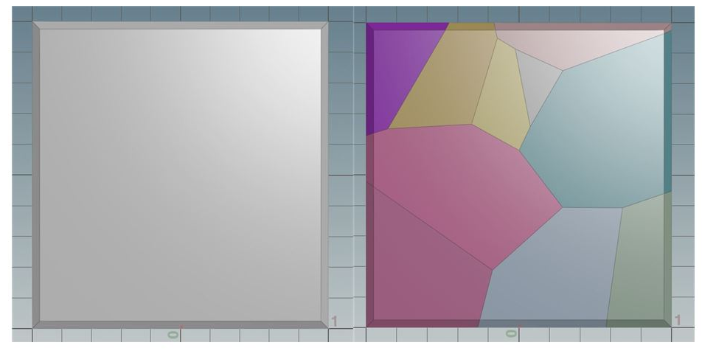

Fig. 3 Split the walls into pieces

B. Setting the constrains

Binding is the key control of the building of the crushing process. Setting the binding process can be divided into five steps, including create dynamics network, create constraint network, create glue constraint, clustering pieces, complimentary dual glue constraints(Fig. 4).

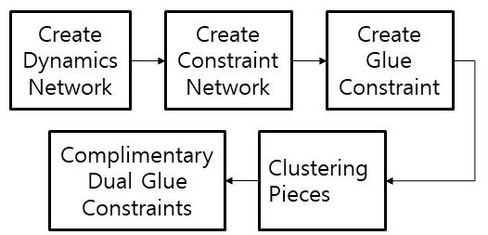

Fig. 4 The flow chart of setting the constrains

Setup simulation dynamic network refers to all the pieces of the model that will produce the basic effects of building collapse with the effects of gravity and rigid bodies. The most important of these are rbd-packed-object node and rigid-body-solver node. The two nodes are used to simulate the default rigid body fragmentation effect in the Houdini software, and then assign the gravity node model. After completing the foundation effect of the building collapse, further details of the collapse need to be adjusted, which is closer to the reality. Creating constraint network is to establish a mutually constrained force between each piece of architecture. The presence of restraint makes the building a whole, and it makes the building no longer collapse instantly when it breaks. The interaction between each fragment makes the broken process more random and more consistent with the physical laws of reality(Fig. 5).

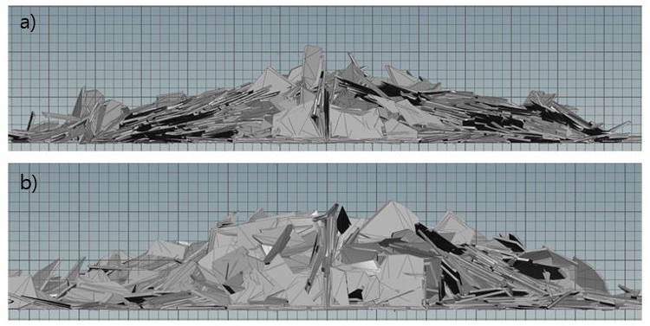

Fig. 5 Building broken, a) Without constrains& b) With constrains

Creating glue constraint contains the sticky connections between the pieces of the building and the foundation that is not affected by external forces. Glue constraint relationship node can establish the cohesive connection, let construction debris have a certain viscosity, thus making the whole building surface has a certain hardness. A collapse occurs only when external forces exceed the surface hardness of the building. By adding and making foundation node, the purpose of setting up a foundation which is not affected by external forces is that in the real situation, the superstructure often collapses, but the foundation part can be preserved intact. Clustering pieces are to simulate the phenomenon of debris of collapsed buildings would produce sizes, use voronoise node can give the whole building model color texture(Fig. 6). Fragments of the same color are reduced to the same cluster, resulting in a large number of buildings with different shapes and sizes.

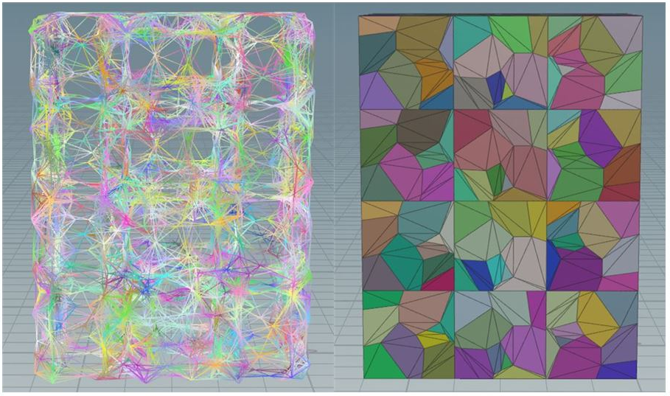

Fig. 6 Voronoise effect & Visual color grouping

Through the expression, the complementary dual glue constraints separate the building surface model from the model inside the building. It reduces the adhesion strength of the building's surface model to make it easier to fall off, while the internal stuck strength of the building slows down at the time of the collapse. The internal and external strength differences are also more consistent with the actual construction collapse, the outer wall first spalling and then the skeleton structure inside the building collapse. The binding work is done here, and the specific node connection is shown in the figure below. It is useful to sum up and set binding. Through various binding additions, the link between the pieces of the building and the structure of the whole building is more rationalized. It is also prepared for the next steps to apply external forces[5].
C. Add force

In film and television works, the collapse of buildings is not only affected by gravity, sometimes accompanied by internal explosions or external shocks. The addition of force makes the crushing effect of building more real and rich. Adding force can be summed up in three steps. First, create metaballs. Second, add the force. Third, force optimization. Metaballs are created by connecting the metaballs node with the force node to achieve the creation of metaballs. Metaballs' role is to give metaballs, and metaballs' movement inside the building hits the debris in the building, causing the building to spatter when it collapses. After the force has been added, it enters the stage of force optimization. First, it adjusts the scope and location of the explosion, which results from metaballs. So it sets up a separate group of building models that overlap with the location of metaballs, making metaballs acting only on the model that the group contains. In order to produce multiple explosions in visual effect, It can combine the vdbfrompolygons node and get-pieces node to get the internal structure of the building. Metaballs randomly appear at any location within the internal structure in order to create multiple explosive points.Finally, it regulates the force intensity of metaballs and the binding intensity of the building debris, etc., until the test of the crushing effect of the building is satisfactory. The specific effect is shown in the figure below(Fig. 7).

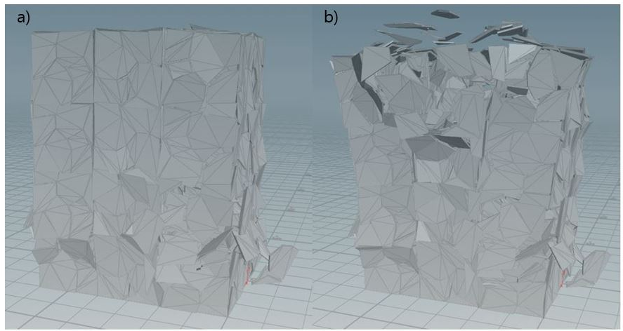

Fig. 7 A single force point & Multiple force points

D. Visual optimization

After finishing the debugging of the crushing effect, it enters the stage of visual optimization. It can be divided into two steps: map optimization and model refinement. It refers to the distinction between the external material and the inner material of the building. In the real life, the exterior wall of the building tends to be covered by a uniform coating or building materials, while the inner material of the wall is the material of the original stone or brick. Therefore, It is of great significance to simulate the actual building crushing effect. The wall model has automatically separated the two regions from inside and outside, merging all the models in the inside region into a group, merging the outside region model into another group. This completes a basic distinction between the internal and external models of the building and then assigns different maps to make the distinction. The model refinement refers to the further refinement and deformation of the debris of the building, making it more consistent with the actual visual effect of the building debris. At this stage, the cross-section of the building debris is very flat, which is not in line with the actual situation in real life. So it is necessary to add concave and convex shape features to the cross-section of the building debris. The pointvop node, the turbnoise node, and the add node are connected in sequence and finally connected with the output node to complete the change of the building debris shape. The significance of turbnoise node is to give the fluctuation rules of the turbulence to the surface of the model so that the shape and wiring of the model are convex and distorted. To adjust the amplitude of pointvop can control the degree of deformation model(Fig. 8). After completing the visual optimization phase, you can enter the export steps of the special effects file.

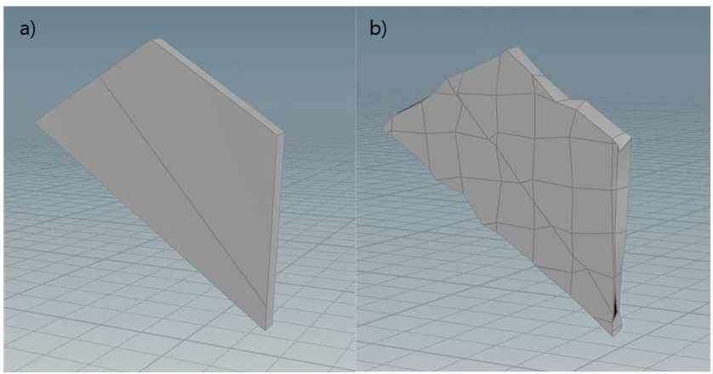

Fig. 8 Building model optimization a) Before & b) After

IV. From Houdini to UE4

In Houdini, the entire fragmentation model with material grouping on the primitive hierarchy is imported into the OUT hierarchy. Export Fbx formats files via rbd_to_fbx node. Fbx file, as a general 3D file format, can also be recognized in Unreal Engine 4. The FBX file derived from the Houdini contains the architectural model and the map, and the animation of the entire broken building rigid body. Create a project in Unreal Engine 4, import the Fbx file exported from Houdini to the content folder in Unreal Engine 4, and drag the model file to the 3D window of Unreal Engine 4. And modify the animation mode of the model into use animation asset, and then drag the animation file of the name ending to the menu bar of anima to play, so that the animation file is associated with the model. Click the play button in the Unreal Engine 4, you can see the broken process of building models in the 3D window. Finally, edit the inside and outside two material, building internal and external mapping can be assigned to the model. At this point, the steps to import the Fbx file into Unreal Engine 4 are completed(Fig. 9). After creating CameraActor and adding level sequence in Unreal Engine 4, the whole process of building rigid body fragmentation are recorded by capture movie, and the final sequence frame is output.

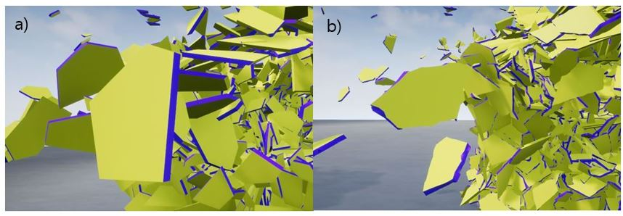

Fig. 9 Internal and external material separation, a) Low quality & b) High quality

V. Conclusion and Proposals

This paper analyzes and summarizes the production process of rigid body crushing in Houdini. The production process of rigid body crushing can be divided into four parts: model making, binding force, adding force and visual optimization. It makes a general summary of the actual operation process of each production link. It summarizes and demonstrates the production process of architectural rigid body crushing effect in Houdini, which can provide a reference for the research field of rigid body fragmentation. It summarizes and summarizes the tedious production process, and provides a more clear and complete production ideas. Houdini and Unreal Engine 4 is also an important research value of this paper. Fbx files are widely used in the field of 3D video game production and are widely used by the software. After the actual test, this paper confirms the special effects produced by Houdini can be displayed normally in Unreal Engine 4 after exporting the FBX file, so the barriers between Houdini and Unreal Engine 4 are eliminated successfully. As a game engine, Unreal Engine 4 is not only widely used in the field of game production, but with the continuous improvement of its function, it has begun to show an upward trend in the field of image production. Therefore, Unreal Engine 4 provides a broader display space for special effects produced by Houdini. On the other hand, Houdini has an unshakable position in the field of special effects production as a professional special effects production software. The addition of Houdini brings great reinforcement to the special effects of Unreal Engine 4. The effects that Unreal Engine 4 cannot achieve in the past can be produced by Houdini now.
In the future research will further improve the construction of special effects of building collapse process. In the production of rigid body crushing effect, the material part of the building model needs to be further enhanced, and the fine degree of rigid body fragmentation can be further improved. This paper simulates the crushing process of the rigid body in the collapse of the building, and the collapse will also produce effects such as smoke and fire. So if you want to simulate a visually stunning building collapse, you need to add more visual effects to the atmosphere. In addition, Unreal Engine 4 also has the ability to produce rigid body fragmentation. In future research, the production process of Houdini and Unreal Engine 4 software can be compared and studied.

References

[1] Z. Xiongxiang, “Research on fracture effect simulation of rigid body,” A Master Thesis Submitted to University of Electronic Science and Technology of China, pp. 1-3, 2014.
- N. Bin Zafar, D. Stephere, M. Larsson, R. Sakaguchi, M. Clive, R. Sampath, K.Museth, D. Blackey, B. Gazdik, R. Thomas, “Destroying LA for ‘2012’,” SIGGRAPH '10 ACM Special Interest Group on Computer Graphics and Interactive Techniques , Article No. 25, 2010.
- M. Seymour, “Art of Destruction,'' fxguide.com, 2011.
- Aurenhammer, Franz, “Voronoi Diagrams - A Survey of a Fundamental Geometric Data Structure,” ACM Computing Surveys, pp. 345–405, 1991.
- P. Ambrosiussen, “Destruction Cleanup - Breakdown,” ambroslussen.com, 2017.

